How to Self-Publish in Oz

A step-by-step guide for Australians planning to self-publish a book.
There’s no better joy to an aspiring author than the arrival of the first book baby. Holding a debut book in your hands, flipping the pages, rubbing the cover and staring at your author picture may seem surreal. Advancements in technology make it possible for you to simply self-publish - if you know how.
This book eliminates the worries from your Australian self-publishing journey by teaching you tips and tricks; what worked for the author and what didn’t.
● The dozen of self-publishing — 1. Write, 2. Drafts/Edits, 3. Register, 4. Market, 5. Layout, 6. Book Cover, 7. Proof, 8. Last Edit, 9. Print, 10. Distribute, 11. Social Media, 12. Website and other marketing.
● Avoid common pitfalls.
● Celebrate your ability.
● TA, B, Cs of self-publishing (Aptitude, Belief, Creativity).
● Drafts, edits, re-drafts and re-edits and the tricks to help.
● Network with your tribe for the processes you can’t do yourself.
● Enjoy the creative freedom of self-publishing.
● Checklists to make the best decisions to produce a book as professionally as a traditionally published one.
● Keeping records that won’t dampen your enthusiasm.
● Free templates - for self-publishing in Australia.
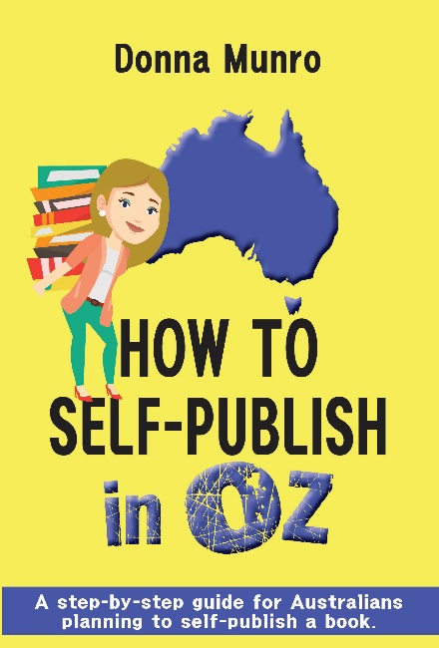
As an indie author of three women’s fiction novels, The Zanzibar Moon, Kendwa’s Secret and Elephant Creek, and freelance writer, Donna Munro can show you how to take the steps. After working in publishing as a book marketing publicist and learning the ropes, she transitioned to self-publishing. She helps other writers achieve their goals by providing newsletters, websites, book design, book covers and other guidance. Skills include excellence in multiple computer platforms and apps, 18 years in the printing industry, writing diploma, graphic design, publishing, administration, marketing and event management.
PRE-RELEASED AT ALL GOOD BOOKS STORES AND
www.donnamunroauthor.com
Paperback: 978-0-6480194-8-0 RRP $25.99
eBook: 978-0-6480194-9-7 RRP $3.99
Pages: 142 Words: 19,300
‘What a great resource for writers like me who are just starting, or fairly new to the whole writing industry. This book not only includes all the basics of what you need to do, it includes so much more advice on the whole writing process, from editing to marketing and more. This is something I will bring out to re-read parts over and over again.’ - Five-star review by Journalist Sharyn Swanepoel
‘What a fab idea for a book. Good on you for helping others self pub. It’s a windy road & there’s so much to learn.’ - Advanced Review by Award-winning author Michelle Somers.
‘Excellent resource for new authors. Step by step guide on how to publish your book. Concise and to the point with pictures, tables, and diagrams to help you along. So glad I found this book!’ - Five-star review by Nicca

